Course Specialist Test 2 Year 12

Student name: ________________ Teacher name: ________________

Task type: Response

Time allowed for this task: ____40_______ mins

Number of questions: _____7______

Materials required: Calculator with CAS capability (to be provided by the student)

Standard items: Pens (blue/black preferred), pencils (including coloured), sharpener, correction fluid/tape, eraser, ruler, highlighters

Special items: Drawing instruments, templates, notes on one unfolded sheet of
A4 paper, and up to three calculators approved for use in the WACE examinations

Marks available: _41_____ marks

Task weighting: _10___%

Formula sheet provided: Yes

Note: All part questions worth more than 2 marks require working to obtain full marks.

Q1 (2, 2 & 3 = 7 marks) (3.2.1-3.2.3)
Consider the functions and .
- State the natural domain and range of .

- Does exist over the natural domain of ? Explain.

- State the rule and natural domain and range of .

Q2 (3, 3, 1 &2 = 9 marks) (3.2.4)
Consider the function with domain .

- Sketch the inverse function on the axes below.
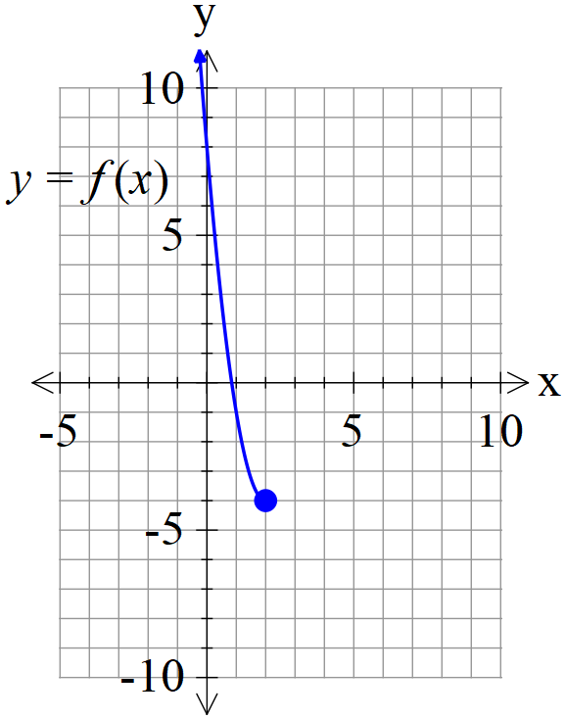
- Determine the inverse function stating its domain. (Show all working)

- Determine

- Determine when exactly.

Q3 (3 marks) (3.2.6)
Consider the inequality is only true for with a constant.
Determine the value of .

Q4 (3 & 3 = 6 marks) (3.2.7)
Consider the following function .
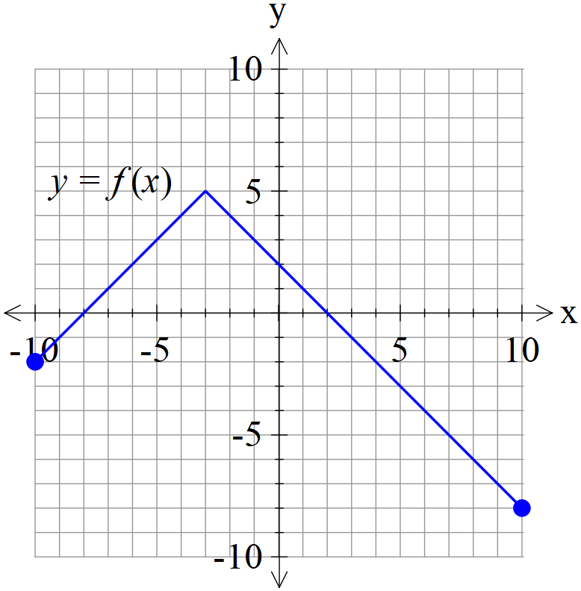
- Sketch on the axes below.
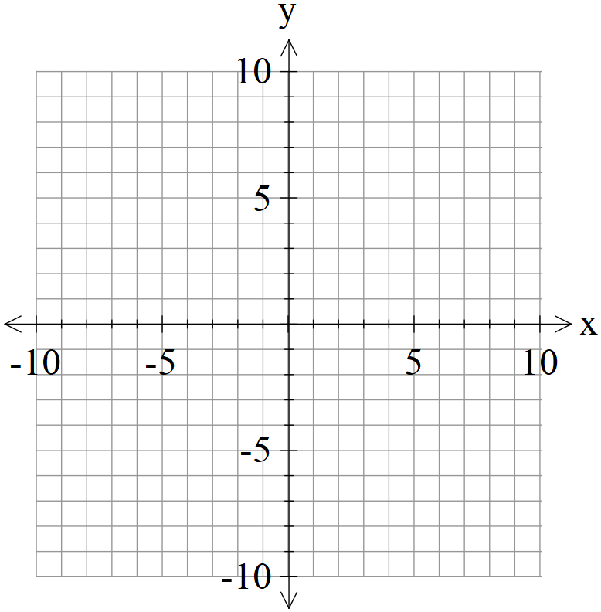
- Sketch on the axes below.
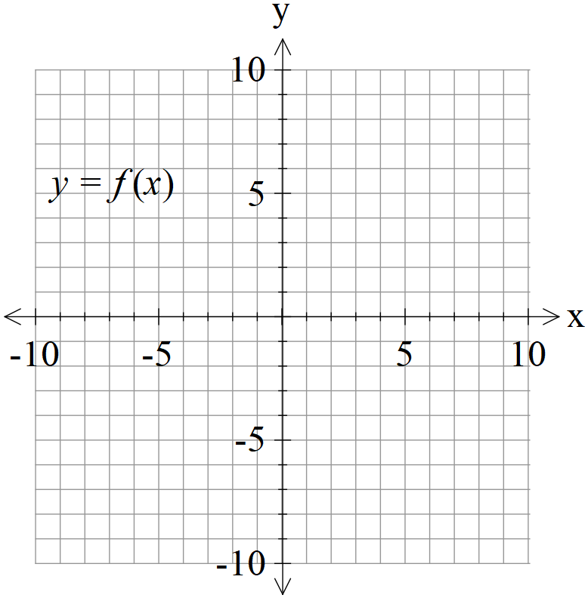

Q5 (3 & 3 = 6 marks) (3.3.3-3.3.6)
Consider two rockets A & B, moving with constant velocities such that at time hours their positions and velocities are as follows:
- Determine the time and distance of their closest approach.

- Given that the rockets leave smoke trails that stay in the air for a long period of time, determine if the smoke trails cross at all and if they do, the point in space. Justify.

Q6 (6 marks) (3.3.4, 3.3.6)
Consider the line and the sphere with a constant.
Determine the value(s) of , to one decimal place, such that:
- The line is a tangent to sphere.
- The line meets the sphere in two places.
- The line misses the sphere completely.

Q7 (4 marks) (3.1.4)
The solutions to the complex equation are plotted in the complex plane. ( is an integer & is a complex constant). Exactly four of the solutions are plotted in the second quadrant,, and no more. Of these four solutions, the smallest argument is .
Determine all possible values of .

